Methodological Worksheet
English Department
Miss Débora Pinto P.

UNIT III. WE ARE WHAT WE EAT
Name:_____________________________________ Grade: 2° medio Date: ______________

Quantifiers
CMO: Usar adverbios cuantificadores (Little, much, many, a lot of, few) en oraciones simples.
Usar adverbios cuantificadores (Little, much, many, a lot of, few) para completar un párrafo.
EXERCISES –QUANTIFIERS
I. Choose the best underlined word from each sentence :
I haven’t got much / many money today.
I’ve got a few / a little fruit and a lot of / many vegetables .
They don’t seem to have much / many free time these days.
He has only read a few / a little chapters of that new book, but he likes it.
A : Does he show much / many interest in sports ?
B : Yes, a lot / a lot of .
There aren’t many / much huge buildings and traffic problems in the small cities so there is no / any stress there.
II: Put some , any , a little , a few or , no into the blanks in the sentences :
- A : How was your skiing weekend ?
B : Terrible ! There wasn’t _________ snow on the mountains.
- A : Hurry up ! There is _________ time to waste. The bus will be here soon .
B : I’m really ready.
- A : What would you like in your coffee ?
B: Just _________ sugar, please.
- A : There are still _________ tickets left for the concert on Friday night.
B : Great . I’ll go and buy one now.
- A : I bought _________ great books from the book-fair this afternoon.
B : Really ! Let me see them .

I. Complete the following paragraph using quantifiers in the box below:

LOTS OF • MANY • MUCH • FEW • LITTLE • SOME • ANY
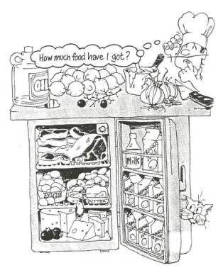

Help the cook to check the food in his fridge. Choose the correct option.
"Hello, my friends. Please help me to fill in the blanks.
Okay, first I need a knife to start dinner. Now let me see if I have got everything. Well, there is a lot of milk, isn’t there? Oh, I’ve only got a _____________ after all. Hum, just half a bottle. And lemons? How ___________ lemons are there? There are plenty. Good! There aren’t ____________(4) tomatoes, are there? Well, there’re only two left. No problem. Have I got enough meat for dinner? Yes, there is ___________ meat. But is there __________ oil? Let me see. Oh, there is ____________ oil left. Well, I will have to buy ______________ . What about butter? Oh no, there isn’t ____________ left, is there? And there are only a ______________ sausages, right? No, actually there are lots of sausages. Good! But I still need ____________ oranges. Not many, just two or three. Oh, I almost forgot. I will also need ___________ apple. Yes, that’s it. Thanks!"

