English Worksheet
English Department
Miss Débora Pinto P. - Mr. Sergio Millán S.

Name:_______________________________ Grade: 8° A Date: October 27 th, 2011
Unit 4: People and Places
Lesson 1: Folk Heroes
Pre Listening: I. Look at the following pictures and put the elements from the box in each image:
Forest – Band – Arrow - Bow

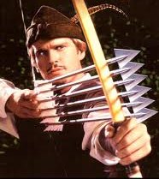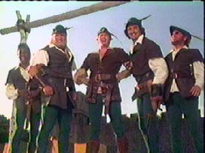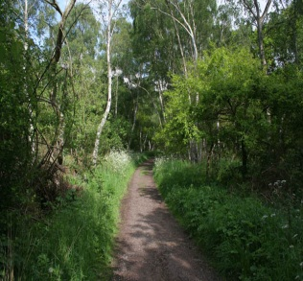
_________________ ____________________ _____________________
_________________ ____________________ _____________________
- Answer the following Questions
- What folk hero is represented in the pictures?
- Daniel Boone b) Robin Hood c) El Zorro

- Where is he from?
- England b) California c) Delaware

- In which epoch the story is developed?
- Renaissance b) Middle Ages c) Prehistory

