English Worksheet
English Department
Miss Débora Pinto P. - Mr. Sergio Millán S.

Name:_______________________________ Grade: 8° A Date: November 3rd, 2011
Unit 4: People and Places
Lesson 1: Super Heroes, The Mask
Pre Listening: I. Look at the following pictures and put the elements from the box in each image:
mask –gangsters– bank - cartoon

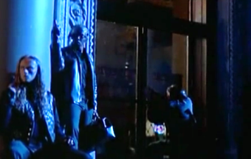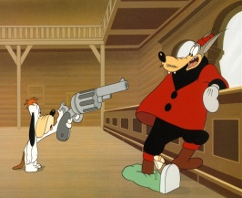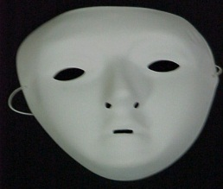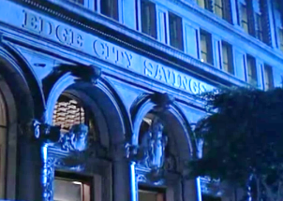
________________ __________________ _________________ _________________
- Answer the following Questions
- What super hero is represented in the pictures?
- Batman b)The Mask c) Spiderman

- Where is he from?
- China b) EEUU c) Russia

- In which genre the story is developed?
- Drama b) Comedy c) Suspence

