English Worksheet
English Department
Miss Débora Pinto P. - Mr. Sergio Millán S.

Name:_______________________________ Grade: 8° A Date: November 3rd, 2011
Unit 4: People and Places
Lesson 1: Super Heroes, The Mask
I. Pre Listening
1. Look at the following pictures and put the elements from the box in each image:
mask –gangsters– bank - cartoon

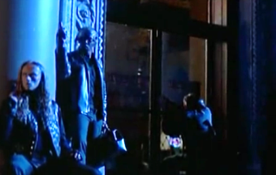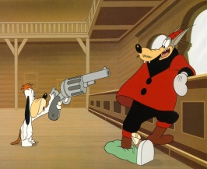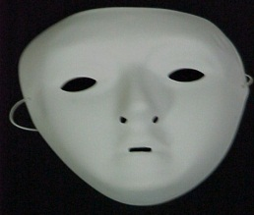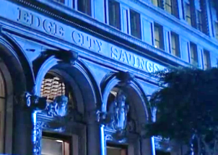
________________ __________________ _________________ _________________
- Answer the following Questions
- What super hero is represented in the pictures?
- Batman b)The Mask c) Spiderman

- Where is he from?
- China b) EEUU c) Russia

- In which genre the story is developed?
- Drama b) Comedy c) Suspence

- WHILE
- TICK the following words when you listen to them:
- ____mask
- ____cartoon
- ____mother
- ____metaphorically
- ____carpet
- ____bottle
- ____Milo
- ____image
- ____picture
- ____book

- WHO SAYS the following phrases? Match in column A with phrases in column B

A B

Stanley What are you doing down there?

Mrs. Peenman Hey, mister...you got the time?

The Police Well, that's what you are, lpkiss, a big nothing.

The band of adolescents I'm just looking for…my mask!

- Recognize in the following situations the correspond feeling in the character:

- When Stanley was standing at the bridge, after the problem of his car he was:

- Hungry
- Sad
- Enthusiastic

- When Stanley arrived at home completely wet and ruined Mrs. Penman´s carpet, she was:
- Nice
- Sleepy
- Angry

- When the gangsters founded that The Mask had taken the money from the bank. They were:

- Surprised
- Honest
- Relaxed

- Why do you think Stanley continue wearing The Mask after know its powers?

- Because he felt like a winner
- Because he felt was the only way to solve his problems and his city´s problems
- Because he felt it was better for his job.

- What do you think is the image that Mrs. Peenman has about Stanley Ipkiss?

- She thinks he is a not very important person
- She thinks is a good person
- She thinks he is a rich person

- Post- Listening Activity

- Read the following sentences and put special attention to the words in bold:

- Stanley found the mask on Thursday. (Day)
- The mask has effect at 8:00 pm. (Hour)
- Stanley started working at the bank in 1996. (Year)
- There was raining at night.

2. What are referring these sentences? (choose one)

- These refer to positions in a certain area. (Prepositions of Place and Locations)
- These refer to the time of the action. ( Prepositions of Time)

- Complete the following Rule:

We use______________________________________________ when we mention a specific time of a certain action.

- Look at the following Conceptual Map:

Prepositions of Time
In  on  Long periods of time  - Years  - Seasons  - Months  Example: in 2011, in Summer, in December  Days and Dates |  | at  at  - Specific Times  Example:  - at five o´clock  - at night  - at lunch
Exercises
- On Monday
- On September, 23

- Complete the following sentences using prepositions of time (in, on, at). Pay attention at the conceptual map at the top.

- You can see the stars__________ night. Well, if the sky is clear....
- In Argentina, you start primary school __________ March, 22.
- I often work until 11 pm. I go to bed__________ night.
- I hate waking up very early __________ 7:00.
- He is working at a tv studio. He is very busy __________ Mondays.
- The course ends __________ January 8.
- We have to go __________ lunch time . Mum is waiting for us....
- We are getting married __________ November.
- She usually goes for walks in the country __________ Saturdays.
- He visites his mother __________ December, 24.
- Homer watches a lot of tv __________ 9:00 pm.
- I usually go back from work __________ five o`clock.
- Tango classes finish __________ December this year.
- Sara goes dancing __________ Tuesdays.
- __________ midnight he eats like a horse.
- Buenos Aires is very hot __________ the summer.

