Matthew Rasler
CS460
1/16/2012

PMBOK Knowledge Area 1 : Project Integration Management
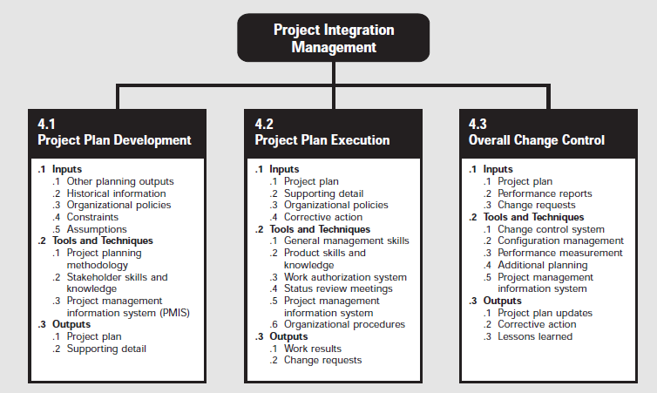
The Project Integration Management Knowledge Area of PMBOK discusses the formality behind the processes required to ensure the proper coordination of the elements and to create a set of processes that satisfy the initial stakeholders’ expectations.. The main processes involved in project integration management are Project Plan Development, Project Plan Execution, and Overall Change Control.
Project Plan Development is a process in which other planning processes, historical data, assumptions, organizational data, and constraints are analyzed and coupled with stakeholder skills and knowledge, and the output of other project management processes to create a consistent and coherent document that guides project execution, documents assumptions and planning decisions, facilitates communication among stakeholders, and provides a baseline for progress measurement and project control. This information is distilled, formalized, and approved into a project plan with supporting details.
The Project Plan, supporting detail, organizational policies, and corrective actions(anything done to bring expected future project performance in line with the project plan) are used as inputs to the Project Plan Execution process. Tools and Techniques used for Project Plan Execution include: General Management Skills, Product Skills and Knowledge, a Work Authorization System, Status Review Meetings, the Project Management Information System, and Organizational Procedures. These tools and techniques provide work results and help identify the need for change requests.
The process of Overall Change Control is concerned with insuring that changes that occur in the execution process are beneficial to the end result, and managing these changes when they occur. Performance reports and change requests are the input for this iterative process. Tools and techniques employed are Configurtation Management, a change control system, performance measurement techniques, and a project management information system to derive and identify project plan updates, corrective actions, and lessons learned.

