Matthew Rasler
CS460-Senior Capstone Project
EARL Group
2/1/2012
PMBOK-Knowledge Area 2: Project Plan Execution
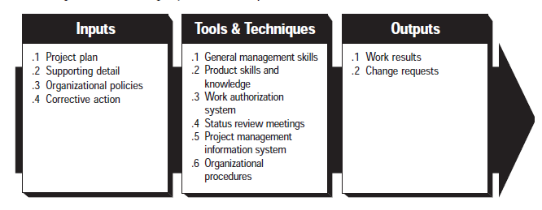
The Project Plan Execution Knowledge Area discusses the area of Project Management devoted to the process of carrying out the project plan. This process is where the majority of the resources will be expended, in that it is where the project is actually developed. This knowledge area is broken up into three subcategories: Inputs to Project Plan Execution, Tools and Techniques for Project Plan Execution, and Outputs from Project Plan Execution (as detailed in the above image). The Inputs to the Project Plan Execution section details the contributing factors to the Project Plan Execution; listed are: the Project Plan, Supporting Detail, Organizational Policies, and Corrective Action. The Tools and Techniques for Project Plan Execution subsection details tools and techniques, of which: General Management Skills, Product Skills and Knowledge, Work authorization system, Status review meetings, the Project management information system, and organizational procedures, are listed. The Outputs from Project Plan Execution subsection details the outputs derived from the execution of the project plan, included as items are: Work Results and Change Results.

