Lesson Plan
(A) Major Concepts
- 8th grade Physical Science
- Chapter 15. Identifying Matter
- Section 15.3. Effects of Pressure and Temperature on Matter
- Boyle’s law & Charles' Law
(B) Performance Objective / Content Standards
- California State Science Content Standards => SM.3.e: Students know that in solids the atoms are closely locked in position and can only vibrate; in liquids the atoms and molecules are more loosely connected and can collide with and move past one another; and in gases the atoms and molecules are free to move independently, colliding frequently.
- Students can explain the compressibility of gas using the particle model of matter.
- Students can predict the effect on the volume of a gas if the pressure or the temperature or the temperature is changed.
- Student will develop knowledge, application, analysis and synthesis levels of reasoning skills and inductive reasoning skills.
(C) Materials and Equipment
- Syringe, marshmallow, computers with the Internet access.
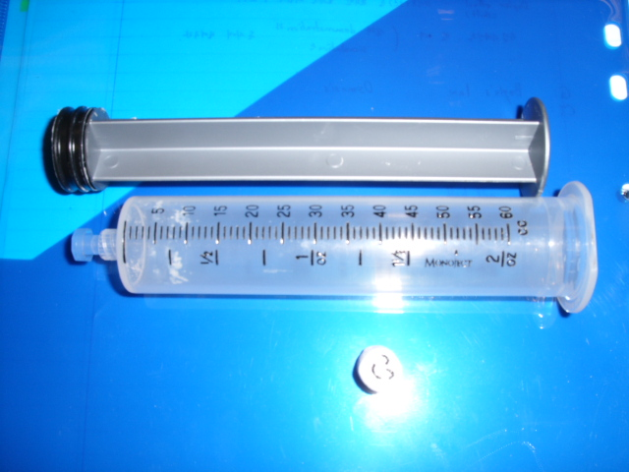
(D) Outline of Lesson (provide a general time frame)
(1) Warm-up Activity (5min.): Vocabulary puzzle.
(2) Introduction. (10min.)
- Review of the unit 15.2 Physical states and properties
- Demonstration with syringe and marshmallow to show the effect of increased pressure on the gas’s volume
- At the normal Pressure (1 atm)
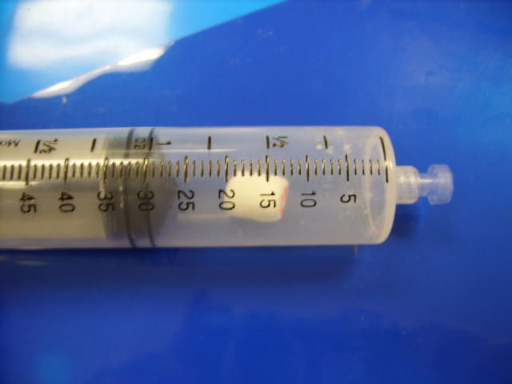

- At the increased Pressure (about 2 atm) => The marshmallow has been squeezed.
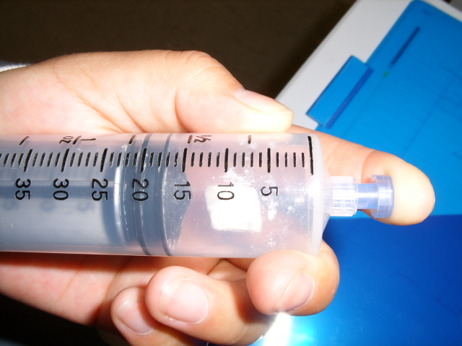
- At the reduced Pressure (0.5 atm) => The marshmallow has swelled.
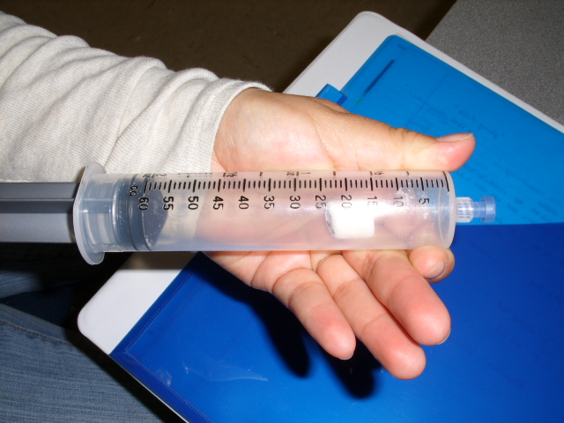
(3) Simulated Experiments (20min) with Boyle's Law and Charles' Law Gizmo
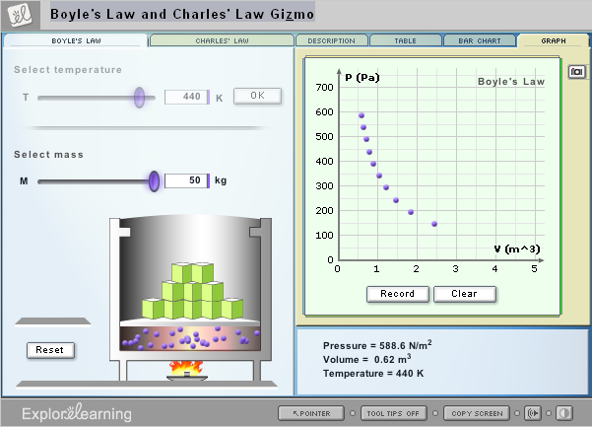
(4) Discussion (10min): Teacher and students talk about the experiments drawing the conclusions.

(5) Summary (5min): Teacher announces the next instruction and assigns the homework.
(E) Homework
- The assessment questions
- Lesson and chapter review problems.
(F) References
http://www.explorelearning.com/index.cfm?method=cResource.dspView&ResourceID=422
(G) Lab paper for students’ handout

Boyle's Law and Charles' Law
1. The objects of the experiments
- You can explain the compressibility of gas using the particle model of matter.
- You can predict the effect on the volume of a gas if the pressure or the temperature or the temperature is changed.
2. Concepts of the experiment
Have you ever heard of a cold-air balloon? Of course not! It's called a hot-air balloon because it will float only when the gas inside it is heated. The heat causes the volume of the gas inside to increase, forcing some gas molecules out of the balloon. As a result, the balloon is less dense than the air surrounding it, so the balloon floats.
Every aerosol can is labeled with the stern warning, "Do Not Incinerate!" This warning should be taken seriously. Incinerating, or burning, an aerosol can would heat the gas inside the can dramatically. With increased temperature and constant volume inside the can, the pressure would increase. This could cause a dangerous explosion.
Both of these situations have to do with how the temperature, pressure, and volume of a gas are related. These interrelationships were first explored by Robert Boyle and Jacques Charles.

Boyle's Law
In this activity, you will explore Boyle's Law, which relates the pressure and the volume of an ideal gas at a constant temperature. The model does not include atmospheric pressure, which would be about 1,000 times greater than the highest pressures shown in the Gizmo.

Exploring Charles' Law
In this activity, you will examine Charles' Law, which relates the temperature and the volume of an ideal gas under constant pressure.
3. Method
  - Open the website- http://www.explorelearning.com.
  - Login and search the bolye’s law.
  - Click “Exploration Guide” and Read the direction carefully.

A. Boyle's Law – Effect of pressure on the volume of gas.
  - Do the simulated experiments with Boyle’s Law at the temperature of 273K. Change the pressure step by step from 5kg(147.15N/m²) to 50kg(1471.5n/m²). Make sure that you open the table and record the data every time like the following picture.
  - Take the snapshot of the table and the graph after finishing the experiments. => If you want to know how to take snapshot and use it, read the following “Help”.
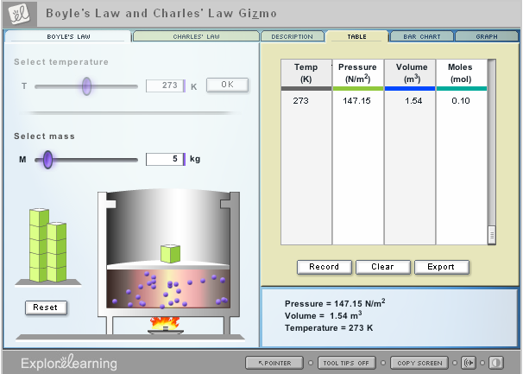

B. Charles' Law – Effect of temperature on the volume of gas.
  - Do the simulated experiments with Charles’ Law at the pressure of 10kg. Change the temperature step by step from 100K to 500K. Make sure that you open the table and record the data every time like the following picture.
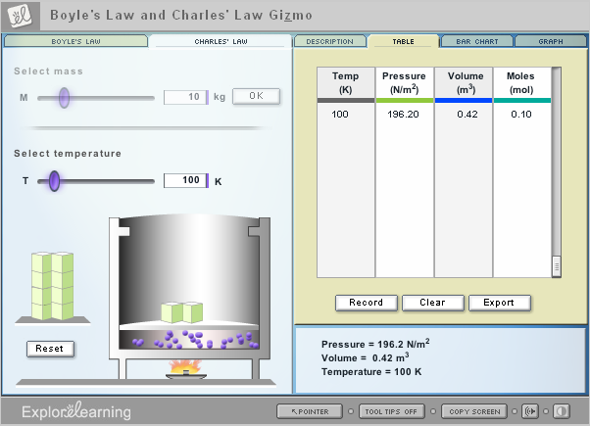
  - Take the snapshot of the table and the graph after finishing the experiments.
4. Data

A. Boyle's Law – Effect of pressure on the volume of gas.
- Paste your data tables here.
- Paste your graphs here.

B. Charles' Law – Effect of temperature on the volume of gas.
- Paste your data tables here.
- Paste your graphs here.
5. Analysis of Data
- What pattern did you notice with respect to the effect of the pressure on the volume of gas?
- How would you describe the relationship between the pressure and the volume of gas at the same temperature mathmatically?
- What pattern did you notice with respect to the effect of the temperature on the volume of gas?
- How would you describe the relationship between the temperature and the volume of gas at the same pressure mathmatically?

6. Discussion and Conclusion
      - How would you explain the volume of gas?
      - Why and how does the volume of gas change depending on the pressure?
      - Why and how does the volume of gas change depending on the temperature?
      - Would you give me examples of our life that use the Boyle’s law and Charles’ law?
7. Assignment: Solve the assessment questions and print the result and bring it to the class tomorrow.
8. Help
Step 1 – Set the Gizmo up however you want.
Any snapshot you take of a Gizmo will capture the current state of the Gizmo. So, anything you can set up in a Gizmo can also become a snapshot!
Step 2 – Take the "snapshot"
fig. 1
To take a snapshot of the entire Gizmo, click the "Copy Screen" [fig. 1] button at the bottom of the Gizmo.
fig. 2
Many Gizmos also give you the option of taking a snapshot of just a portion of the Gizmo, like a graph, bar chart, etc. To copy the snapshot area, click on the camera icon (fig. 2).
fig. 3
(Note: In our older Gizmos, click the icon shown in Figure 3 to take a snapshot of the entire Gizmo, or click the clipboard icon [Figure 4] to capture the snapshot area of the Gizmo.)
Now the snapshot is stored on your computer's clipboard.
fig. 4
Step 3 – Paste the snapshot
Open a word processing document, such as a Microsoft Word file, place your cursor where you'd like the snapshot to go, and paste it.

