South of the world

Chiloé: the island of legends
Prior to visiting this land it is a must to become familiar with the stories that surround its inhabitants with magic.
Tuesday, May 25, 2010
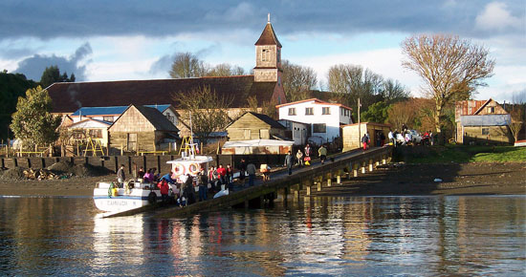The importance of these popular legends has to do with the marked identity of Chiloé

1

Other languages
- Chiloé: la isla de las leyendas
During the rainy winter nights, the inhabitants of Chiloé, off the coast of the region of Los Lagos, carry out an age-old tradition each year. They sit around a fireplace and begin to tell children or foreign visitors about the different beliefs that make up the local mythology that characterizes and gives this magic island its own special identity.

The lakes, lagoons, rivers, abundant forests and a temperate rainy climate marked by fog and strong winds endow this island in the south of the world with very special conditions that stimulate its inhabitants into keeping the traditional beliefs alive.

The meaning that the late Oresthe Plath, a researcher of Chilean folklore, gave to these legends had to do with seeking to make sense of the unknown. “Myths are the explanations that primitive men give to natural phenomena they can’t elucidate, and thus attribute them to divine and superhuman personages”, he said. But although in many places these stories have remained forgotten in books, in Chiloé they are still part of daily life.

The importance of these popular legends has to do with the marked identity of Chiloé, where traditions such as folkloric celebrations, handicrafts, typical cuisine and rustic labor prevail that are very different even from continental Chile.

These stories that make up the popular culture of the Chilean people, as well as their origins, have given rise to a considerable number of marketable products. There are films on the subject (such as “Caleuche, el llamado del mar”, directed by Sergio Olguín), books, comics, poems, songs and a large variety of art and handicrafts inspired on these traditions.

Where does this mythology come from? Like the rest of the south of Chile, in their great majority these are “mestizo” myths and legends, i.e. that mix the Spanish traditions with stories of the indigenous peoples who inhabited these lands. And Chiloé is where you can find the largest variety of these beliefs.

El Caleuche
The Caleuche legend tells the story of a phantom ship that carries wizards and witches and sails along the south Pacific, appearing sporadically close to beaches during the night. When there is low tide you can distinguish in the fog something like a highly illuminated vessel with music on board, as if a party were in full swing. The myth is that those who witness this spectacle –fishermen, in general– turn into marine animals such as seals or sea lions, or are simply borne away on the Caleuche.

La Pincoya
This is a blonde mermaid that patrols the beaches of the south of Chile to protect the ocean and save the shipwrecked. The legend states that her task is to make the fish fecund, so that their abundance or scarcity depends on her. It is believed that when a fisherman witnesses the dance of this mermaid, it is a sign of abundance.
El Trauco
This personage, one of the most representative of Chilote mythology, is also known as Huelle, Pompón del Monte or Chauco. He embodies the devil most feared by the inhabitants of the island.

His deformed and terrifying appearance has to do with his fantastic nature. He eats forest fruits such as “naranjitas” (little oranges) that are produced by a typical Chilote plant, the quilineja (Luzuriaga radicans), a creeper that you can usually see climbing around trees. It grows in places where there is high humidity, such as this land.

The villagers believe that when a very young and single woman gets pregnant it is the result of her encounter with the Trauco.

El Cuchivilu
This word, that alludes to an aquatic animal, is very important in Chiloé mythology. Its figure has to do with the strange and sudden destruction of the old fishing pens, for which it is held responsible.

Its appearance is a mix between a sea lion, serpent and pig. Its image is associated with the lagoons or swamps that characterize Chiloé.

El Camahueto
Similar to a calf, this mythological being is said to possess a golden horn on its forehead, to which supernatural powers are attributed.

According to the inhabitants of Chiloé, it can be found in lagoons and rivers, where it sleeps for 25 years. But when it wakes up, it destroys everything in its path, leaving behind the characteristic furrows that can be seen all over the island.

