INTRAOPERATIVE CONSIDERATIONS FOR DEHORNING CATTLE
In order to be completely prepared for a surgery of this nature; three main aspects must be addressed namely restraint, pain management and anti-infective care. Since dehorning is relatively simple to perform these elements are essential for making them uncomplicated.
Appropriate and adequate methods of restraint must be taken to ensure the safety of both handler and animal. Squeeze chutes, head/nose bars, nose tongues and halter should be used if available.
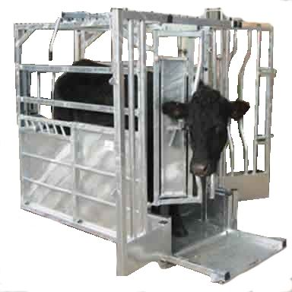
Squeeze Chute
For dehorning the squeeze chutes, head/nose bars and specified head restraints are helpful in keeping the animal stationary for the procedure. In this lab halters and nose tongue were used for restraint. In addition, chemical restraint is a vital tool as it minimizes the need for physical restraint; therefore the use of sedatives such as Xylazine was considered.
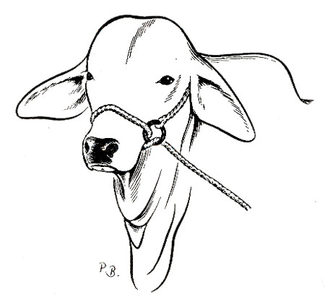
Halter head restraint.
Pain management prior, during and post-operatively must be taken into account for this procedure, especially for older cattle such as our patient. Not only is this an animal welfare issue but it also renders the animal more manageable during the process and it allows for undisturbed healing by the animal post -operatively. Analgesics were considered and flunixin was chosen for it availability and NSAID properties. Furthermore local anaesthetics (e.g. Lidocaine) were considered for auxiliary analgesia directly at the site of surgery. You should check for palpebral reflex or needle pricking which will indicate if the area of interest is fully anaesthesised.
In similarity with invasive procedures, possible infection is a top consideration. In the case of older cattle(heifer) it is even more significant as the frontal sinuses are exposed after dehorning.
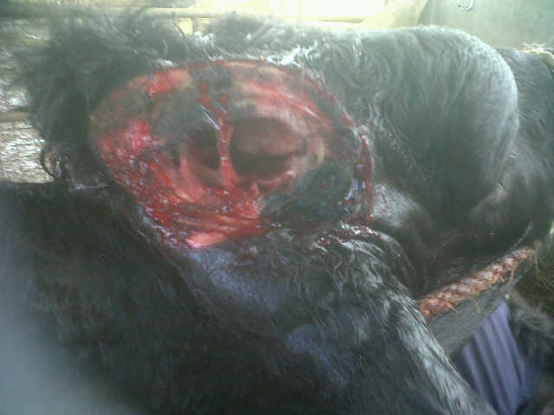

In order to avoid infection firstly cleanliness of the tools and operator is necessary and incases where multiple animals are operated on, it helps to prevent the spread of diseases such as anaplasmosis, bluetongue and bovine leukosis.
When done correctly, dehorning will both remove the horn and also prevent it from regrowing
during the life of the animal. The horn grows from the skin at the base of the horn. A properly
dehorned animal should have a 1/4 – 1/2 inch wide ring of skin at the base of the horn removed

Haemorrhage is another major concern. Although if done correctly this procedure should not result in massive bleeding even though there is still a risk due to inexperienced operators and clotting disorders of the animal and thus instruments such as haemostats and thermocautery should be readily available.
Horn removal in older animals can lead to post-operative problems of hemorrhage, tissue necrosis, bone fracture, sinusitis, and even death. The wound caused by this amputation can take three months or more to heal.

