PROPER HANDLING OF INTESTINES

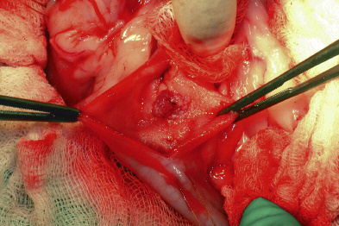

Crushing of the bowel ends can be minimized by grasping just the serosa of the bowel with the tips of the forceps. Note that the forceps on the left (above) are handling the bowel by just grasping the serosa (correct), whereas the forceps on the right are grasping the full thickness of the bowel (incorrect).

