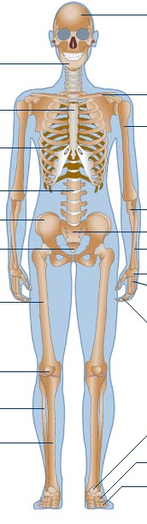

Radius Phalanges (use twice) Pelvis Ribs

Mandible Coccyx Cranium Sternum

Clavicle Fibula Tarsals Carpals

Spine Femur Ulna

Humerus Metatarsals Patella

Metacarpals Sacrum Tibia

**WORD BANK:**