ANATOMY OF THE HOOF
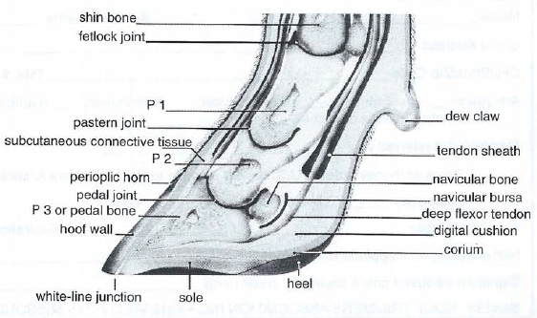
Cattle, sheep, goats, and pigs are cloven-footed animals, meaning that the hoof consists of two digits, instead of one solid entity like that of a horse. The two digits are analogous to the third and fourth fingers of the human hand. The claws are named by their relative location on the foot. There is the outer, or lateral claw, and the inner, or medial claw. In cattle, the lateral claw is slightly larger in the back feet, while the medial claw is the larger claw in the front feet. The space between the two claws is called the interdigital clef; the area of skin is called the interdigital skin. The different surfaces of the claws are named according to their relative position to the interdigital cleft: the abaxial surface is the outer wall of each claw, and the axial surface is the inner wall. The hoof is described from the outside moving in, beginning with the hard outer covering of the hoof, known as the hoof all, or horn. The horn is a hard surface, structurally similar to the human fi ngernail, but functionally like the epidermis of the skin. The cells that form the horn are produced by the tissue directly beneath the hoof wall, called the corium, at the hoof head. The corium is a nutrient-rich tissue that contains many important blood vessels and nerves inside the hoof. The corium is similar to the quick of the fingernail in humans in that it continuously produces new cells that are then gradually pushed away from the quick. As the cells are pushed away from the corium, they die and produce the hard, new outer growth that we see both in our own nails and in hoof growth. At this point the cells are said to have been keratinized, or cornified. The new growth comes out at the coronary band, the point where the hoof meets the hairy skin on the animal’s foot. The soft, new hoof growth that has just come to the surface is referred to as the perioplic horn and is shiny and holds in the moisture of the hoof. Underneath the hoof is a slightly softer region, called the sole. The tissue that makes up the sole is produced by the corium of the sole, and is suppler than the horn of the hoof wall. The point where the hoof wall is bound to the sole is called the white line. The white line is a somewhat flexible junction between the sole and wall, allowing the hoof to be more flexible as the animal moves. The front region of the sole is called the toe, and the two bulbs at the opposite end of the foot are referred to as the heel bulbs. Inside the hoof, there are bones that play a key role not only in forming the shape of the hoof, but also in serving as a support structure for the leg and the rest of the body. The sole should be from five to seven millimeters thick for the inside of the hoof to be protected properly. Directly above the sole is the corium, which is below the digital cushion. The digital cushion is a pad of fatty tissue that serves to protect the corium, as well as to aid in blood transport in the leg. It also serves as a shock absorber for the digital phalange bones. The pedal bone is directly above the digital cushion and is the largest bone in the hoof. The pedal bones provide the framework for the general shape of each claw, and they are key components in the movement of the animal. The pedal bone is attached to the corium by sensitive connective tissue called the laminar tissue, or laminae. The laminae holds the animal suspended in its hoof. The deep flexor tendon is attached to the back portion of the pedal bone, making it very important for locomotion and flexion of the foot. The short pastern bones (P2) snugly fits into the top of the pedal bone, forming a condular joint referred to as the pedal joint. Seated directly behind the pedal joint is a small bone called the distal sesamoid bone (navicular bone), which serves as a fulcrum for the movement of the joint. The long pastern bone (P1) then fits into the top of the short pastern bone, forming the pastern joint. Above the long pastern bone is the fetlock joint and above that the cannon bone of the lower leg. The pedal bone is the only bone of these three that is completely inside the actual hoof, while the pastern bones serve to connect the hoof to the rest of the leg. The bones in the hoof do not entirely formulate the movement of the foot and the leg. Several tendons allow the animal its range of motion. For example, the deep flexor tendon attaches to the pedal bone and goes up the back of the leg, allowing the animal to flex its foot; the extensor tendons in front allow the animal to pick up its foot and move it forward. Directly below the flexor tendon is the digital cushion, which aids in pumping blood throughout the foot and up the rest of the leg as well as serving as a shock absorber to protect the sensitive tissues from the bones of the hoof. The structure of the equine foot is very similar to the cloven-footed hoof anatomy described above, but there are a few differences. First and foremost, the hoof of the horse consists of one continuous structure. The outer wall is the same as that of a cow or sheep; however, the sole is slightly different. In the middle of a horse’s sole is a V-shaped cleft, called the frog. The frog serves as a cushy, weight bearing surface that absorbs shock and aids in pumping blood throughout the hoof and up the leg. On either side of the V there are deep clefts, followed by ridges called the bars. The bars are a continuation of the hoof wall from the heel. The main difference is not in the structure, but the name of the pedal bone. The third phalange is called the pedal bone in most animals but is often known as the coffin bone in the equine hoof; however, despite the difference in name, the function is the same.

