[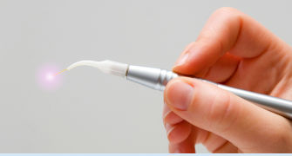](http://www.google.ro/url?sa=i&rct=j&q=&esrc=s&frm=1&source=images&cd=&cad=rja&uact=8&ved=0CAcQjRw&url=http://netdent.ro/Instrumente-si-materiale-dentare/laserul-dentar-o-alternativa-reala-in-clinicile-stomatologice-din-romania.html&ei=4rq8VPiAJdH5aqqugUA&bvm=bv.83829542,d.d2s&psig=AFQjCNEUHa1XEb2DL2VAgahPi4H3JsdiWg&ust=1421741134493448)

[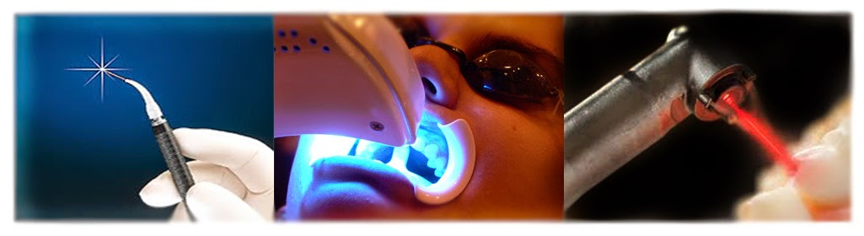](http://www.google.ro/url?sa=i&rct=j&q=&esrc=s&frm=1&source=images&cd=&cad=rja&uact=8&ved=0CAcQjRw&url=http://totuldesprefizica.blogspot.com/&ei=9bq8VLfoPIrbaLj4gNgH&bvm=bv.83829542,d.d2s&psig=AFQjCNEUHa1XEb2DL2VAgahPi4H3JsdiWg&ust=1421741134493448)