Creador

Henry Ford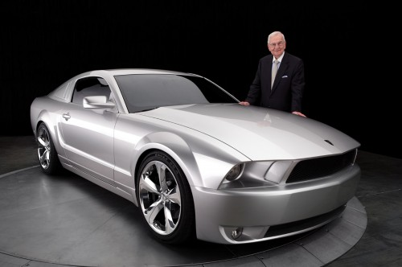
Ford Mustang

