**REQUIRED KNOWLEDGE TO TEACH LOGARITHMS (EXCLUDING CALCULUS OF)**

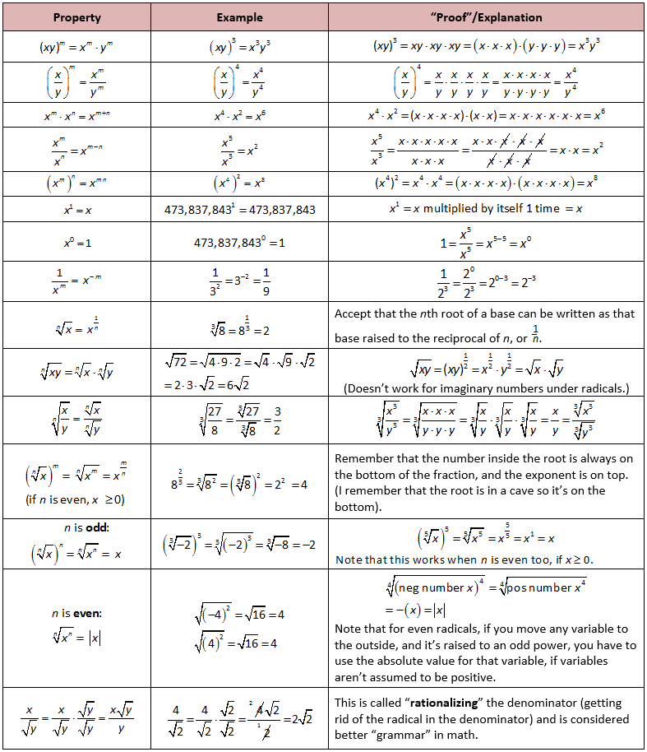**Power Laws and Indices (Year 9, Year 10 / Year 11, Year 12)**

1. A power is the product of factors, where all are the same. For example, 24 = 2 × 2 × 2 × 2 is the fourth power of 2. The number 2 is called the base. The number 4 is called the index or exponent.
2. Special cases: For any number *x*, *x*^1 = *x* and x^0 = 0 (x = 0, undefined)
3. The inverse of x i.e. 1/x = x-1, this can be extended to the general case; 1/xm = b-m.
4. The use of Scientific Notation.
5. Understand and use the Index Laws (shown right) (1 – 8 covered in Year 9)
6. Understand and use the Index Laws (9 - 15 covered in Year 10A or 11)
7. Indices can be extended to rational numbers. For example, a (m/n).
8. Powers with rational indices can be represented in Surd or Root form. Surds can be rationalised by removing radical from denominator.
9. Roots and fractional Indices of the form 1/n are equivalent.
10. Power laws can be extended to x (Irrational Number) for x>0, using limits. The number e is a special case.

**Algebra and Numbers**

1. Different types of numbers exist e.g. counting numbers, whole numbers, rational numbers, irrational numbers, real numbers and their properties.
2. Numbers and variables must obey the fundamental laws of the **Algebra** of **Real Numbers** that is: 1) **Closure**: a + b and ab are real numbers, 2) **Commutative**: a + b = b + a, ab = ba, 3) **Associative**: (a+b) + c = a + (b+c), (ab)c = a(bc), 4) **Distributive**: (a+b)c = ac+bc, 5) **Identity**: a+0 = 0+a = a, 6) **Inverse**: a + (-a) = 0, a(1/a) = 1, 7) **Cancelation**: If a+x=a+y, then x=y, 8) **Zero-factor**: a0 = 0a = 0 9) **Negation**: -(-a) = a, (-a)b= a(-b) = -(ab), (-a)(-b) = ab.
3. **Golden Rule of Algebra**: Any mathematical operation can be performed on one side of an equation so long as the identical operation is performed on the other side of the equation.
4. **Rules for Fractions**: 1) Factors with a common denominator can be expanded, 2) Fractions can be added by finding a common denominator, 3) Products of fractions can be carried out directly and 4) Quotients of Fractions can be evaluated by inverting and multiplying. **Can be expanded to include variable expressions.** Including same and different algebraic variables on the denominator.
5. Using the Rules for Fractions for **cancelling**, **multiplying** and **dividing** algebraic fractions.
6. Combining **index** **laws** with algebraic **fractions** to simplify algebraic expressions.
7. The Algebraic techniques of **expansion**, and **factorisation** a means to simplify an expression including special cases of difference and sum of squares.
8. **Substitution** of expressions in brackets into algebraic expressions.
9. Solving **simultaneous** **linear** equations using a variety methods.
10. Solving **linear** equations involving **algebraic fractions**.
11. Quadratic Equations, Roots of Equations, Polynomials, Sum and Difference of Cubes.
12. Factorisation of polynomials.

**Graphing and Functions**

1. Definition of Cartesian plane and how to **plot** points and **draw** curves.
2. Define the properties for **tangential** and **parallel** lines to simple curves.
3. **Graph simple non-linear** relations with and without the use of digital technologies.
4. Explore the algebraic and **graphical** representations of functions including, **hyperbolas** and **exponentials**.
5. **Graphically** **solving** equations.
6. Definition of a function as a **mapping** between **sets** and a **rule** to define one variable in terms of another.
7. Understand what itmeans **Map** of functions onto the Cartesian plane.
8. Us the language of functions, including **Dependent** and **Independent** variables, **Domain** and **Range** of a function.
9. Difference between function (single-valued and a relationship) and how this might relate to Domain or Range.
10. Familiarity with the **algebraic** and **graphical** meaning of the **Inverse** of a function.
11. The how to **generate** and understand the impact of **Translations** and **Dilations** on any Function.

**Exponential**

1. Recognise the **qualitative** features of the exponential graph including **asymptotes**, **intercept** its **translations** or **dilations**.
2. Recognise the impact of using **positive** and **negative** **indices** on the curve.
3. Identify **contexts** suitable for **modelling** by **exponential** functions and use theorem to solve **practical** problems
4. **Solve** **equations** involving exponential functions using technology and algebraically in **simple** cases (no logarithm).
5. Use limits on (ax – 1)/x (x approaches 0) to define that only base, ‘e’, exists where the derivative equals the function. Show this graphically, explain the irrational nature of ‘e’. (Not required for functional explanation of logarithms but handy information).
6. Define an exponential function as ex and apply power and indices laws to the manipulation of exponentials.
7. Use the exponential function and its derivatives to solve practical problems.

**Arithmetic and Geometric Sequences**

1. Knowledge of Arithmetic and Geometric Sequences
2. Since Logarithms turn geometric terms into arithmetic terms there is a type of question on Logarithms that involves the use of Geometric Relationships being converted into Arithmetic Relationships and simplified using Logarithms?

# Bibliography for Assignment 3

A B Cron. (2014). Exponents &amp; Logarithms. Retrieved May 30, 2017, from <https://www.geogebra.org/m/pyZEvRz>3

Boyadzhiev, I. (2014). Logarithmic Spiral and Fibonacci Numbers. Retrieved May 30, 2017, from <https://www.geogebra.org/m/DbQxZyN7>

Engage Education. (2015, October 8). Maths Methods. Retrieved May 29, 2017, from <http://wiki.engageeducation.org.au/practice-exams/maths-methods/>

Explore Math. (2017). Lesson Plan - Logarithmic Functions. Retrieved May 30, 2017, from <http://www.cii.illinois.edu/InquiryPage/bin/docs/u11733_log_lab1.pdf>

ExploreLearning. (n.d.). Logarithmic Functions Gizmo : Lesson Info : ExploreLearning. Retrieved May 30, 2017, from <http://www.explorelearning.com/index.cfm?method=cResource.dspDetail&ResourceID=145>

Fogleman, A. (2005). Logarithm. Retrieved May 29, 2017, from <https://www.thocp.net/reference/sciences/mathematics/logarithm_hist.htm>

Hyperphysics. (2017). Algebraic Properties. Retrieved May 29, 2017, from <http://hyperphysics.phy-astr.gsu.edu/hbase/alg2.html>

Morgan, J. (2014). Logs. Retrieved May 27, 2017, from http://www.resourceaholic.com/2014/04/logs.html

School Curriculum and Standards Authority. (2016a). Mathematics Methods Year 11 Syllabus. Retrieved May 29, 2017, from <http://senior-secondary.scsa.wa.edu.au/__data/assets/pdf_file/0019/10693/Mathematics-Methods-Y11-Syllabus-AC-ATAR-2016-GD.pdf>

School Curriculum and Standards Authority. (2016b). Mathematics Methods Year 12 Syllabus. Retrieved May 29, 2017, from <http://senior-secondary.scsa.wa.edu.au/__data/assets/pdf_file/0020/10694/Mathematics-Methods-Y12-Syllabus-AC-ATAR-GD.pdf>

School Curriculum and Standards Authority. (n.d.). Mathematics v8.1 Years 9 and 10. Retrieved May 28, 2017, from <http://k10outline.scsa.wa.edu.au/home/p-10-curriculum/curriculum-browser/mathematics-v8>

SCSA. (2016a). 2016-ATAR-course-examination-report-Public-version-MAM. Retrieved May 29, 2017, from <http://wace1516.scsa.wa.edu.au/__data/assets/pdf_file/0003/369471/2016-ATAR-course-examination-report-Public-version-MAM.PDF>

SCSA. (2016b). Mathematical-Methods-Calc-Assumed-Exam-2016. Retrieved May 29, 2017, from <http://senior-secondary.scsa.wa.edu.au/__data/assets/pdf_file/0019/344503/Mathematical-Methods-Calc-Assumed-Exam-2016.PDF>

SCSA. (2016c). Mathematical-Methods-Exam-Calc-Free-2016. Retrieved May 29, 2017, from <http://senior-secondary.scsa.wa.edu.au/__data/assets/pdf_file/0020/344504/Mathematical-Methods-Exam-Calc-Free-2016.PDF>

SCSA. (2016d). Mathematical_Methods_Sample_Calc_Free_exam_2016. Retrieved May 29, 2017, from <http://senior-secondary.scsa.wa.edu.au/__data/assets/pdf_file/0004/10687/Mathematical_Methods_Sample_Calc_Free_exam_2016.PDF>

SCSA. (2016e). Mathematics_Methods_Sample_Calc_Assumed_Exam_2016. Retrieved May 29, 2017, from <http://senior-secondary.scsa.wa.edu.au/__data/assets/pdf_file/0006/10689/Mathematics_Methods_Sample_Calc_Assumed_Exam_2016.PDF>

SheLovesMaths. (2017). Exponents and Radicals. Retrieved May 29, 2017, from <http://www.shelovesmath.com/algebra/intermediate-algebra/exponents-and-radicals-roots/>

STEM Learning Ltd. (2010). Simplifying Expressions Using the Rules of Logarithms | STEM. Retrieved May 30, 2017, from <https://www.stem.org.uk/elibrary/resource/32050>

Supporting Australian Mathematics Project. (2017). Year 9 Indices. Retrieved May 29, 2017, from <http://www.amsi.org.au/ESA_middle_years/Year9/Year9_md/Year9_1a.html>

TED - Arthur Benjamin. (2013). The Magic of Fibonacci Numbers - YouTube. Retrieved April 30, 2017, from <https://www.youtube.com/watch?v=SjSHVDfXHQ4>

Watson, C. (2017). ClassPad eActivities. Retrieved May 30, 2017, from <https://charliewatson.com/casio/cpeActivity.php>

Whitehouse, S. (2011). A level Maths: Logarithms worksheets and revision. Retrieved May 30, 2017, from <https://www.tes.com/teaching-resource/a-level-maths-logarithms-worksheets-and-revision-6146791>

Wikipedia. (2017, April 7). Logarithmic spiral. In *Wikipedia*. Retrieved from <https://en.wikipedia.org/w/index.php?title=Logarithmic_spiral&oldid=774347021>