Who Done It?

MCLL Library guide: libraryguides.mcgill.ca/mcll

Catalogue (WorldCat Discovery): mcgill.on.worldcat.org/discovery

The catalogue includes holdings of McGill Library and other libraries worldwide, in all format types. These include eBook, eAudiobook, and eVideo.

TIP: Search for items on a topic and take a look at all formats available:

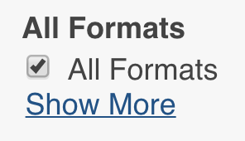

Newspapers

The Library catalogue has links to newspapers and other periodicals, but does not include the contents of all of the periodicals. There are, however, databases that allow you to search current and historical newspapers.

Guide to finding newspapers and searching their contents:
www.mcgill.ca/library/find/newspapers

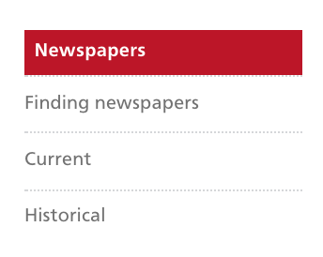
Databases

The Library catalogue has links to journals and other periodicals, but does not include the contents of all of the periodicals.

Databases A to Z: libraryguides.mcgill.ca/az.php

Crime
Crime, Punishment, and Popular Culture, 1790-1920:
mcgill.on.worldcat.org/oclc/928409784

Criminal Justice Database: mcgill.on.worldcat.org/oclc/54901347

Criminal Justice in America: U.S. Attorney General Opinions, Reports, and Publications: mcgill.on.worldcat.org/oclc/123029007

Biography

Ancestry: mcgill.on.worldcat.org/oclc/61265653

Dictionary of Canadian Biography Online: mcgill.on.worldcat.org/oclc/463897210

American National Biography Online: mcgill.on.worldcat.org/oclc/44109626

World Biographical Information System (WBIS) Online: mcgill.on.worldcat.org/oclc/57422932

April Colosimo
MCLL Liaison Librarian
McGill University
april.colosimo@mcgill.ca
514 398-4765

