EROSIONE DEI LITORALI
Attualmente è prevalente il fenomeno erosivo sui litorali a causa dei molteplici interventi dell’uomo che si sono succeduti nel tempo.
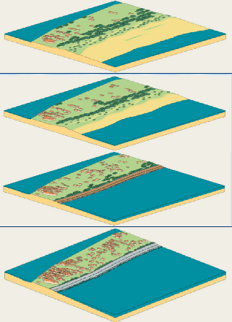
EROSION OF LITTORALS
During the Republic of Venice domination, silting up of the lagoon used to prevail because of sediment coming from the rivers; nowadays an important loss of sediment occurs due to human interventions that we have already seen.In 18th century the force of the sea was a threat to the inhabited areas; for this reason an important defence structure was realized with stones: the famous Murazzi. The photo shows the damaged Murazzi after the big storm in November 1966.

