Ancient Mesopotamia Unit Project
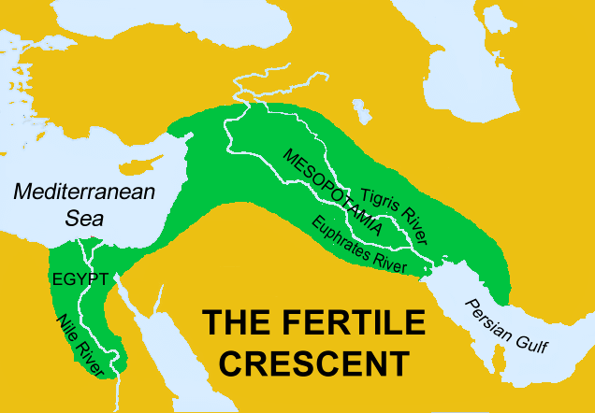
WHAT: The end project for our Ancient Mesopotamian Unit will be a podcast focusing on the many themes discussed within the unit. You will be creating commercials in an attempt to persuade people to move to Mesopotamia. You must include the following themes in your commercial:
- Location
- Place
- Human/Environment Interaction
- Movement
- Regions
**Remember: You want to persuade people to move to Mesopotamia. Think about the properties involved with the themes posted above. Why should people move to Mesopotamia?
WHO: Although there will be many opportunities for collaboration, the end project will be an independent assignment. Each of you will turn in your own commercial/podcast. Once you have finished your podcast you must have a classmate review it and listen to any suggestions he/she may have. Complete the peer feedback form after viewing one another’s work.
HOW: To create our commercials we will be using Podcast Producer on our class set of laptops. Before you begin making your commercial you must make a script/outline of what you want to include in your commercial. You must get your outline approved before beginning your commercial.

Good Luck and Have Fun!

