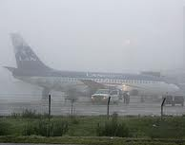
When she arrived to the airport, she found
that her flight have been delayed because of the
bad weather.

